A FIELD PROJECT REPORT

ON

**HOSTEL MANAGEMENT**

**BACHELOR OF TECHNOLOGY**

in

**COMPUTER SCIENCE ENGINEERING**

Submitted by

|  |  |
| --- | --- |
| B.Manoj kumar | (231FA04847) |
| D.Prasannajaneyulu | (231FA04B80) |
| J.Saikumar | (231FA04B94) |
| K.Divya | (231FA04D44) |
|  |  |
|  |  |

**Under the guidance of**

*Mr. Nanda Kishore*

**HOD Nominee**

*P. Kiran Kumar Raja*

*Simhadri Chinna Gopi*

Assistant Professors, Department of CSE



DEPARTMENT OF COMPUTER SCIENCE & ENGINEERING

VIGNAN'S FOUNDATION FOR SCIENCE, TECHNOLOGY AND RESEARCH Deemed to be UNIVERSITY Vadlamudi, Guntur.

ANDHRA PRADESH, INDIA, PIN-522213  **March 2025**



**CERTIFICATE**

This is to certify that the field project entitled “VIGNAN HOSTEL MANAGEMENT” being submitted by (B.Manoj kumar & 231FA04847), (D.Prasannajaneyulu & 231FA04B80), (J.Saikumar & 231FA04B94), and (K.Dviya & 231FA04D44) in partial fulfilment of Bachelor of Technology in the Department of COMPUTER SCIENCE ENGINEERING, Vignan’s Foundation For Science Technology & Research (Deemed to be University), Vadlamudi, Guntur District, Andhra Pradesh, India, is a bonafide work carried out by them under my guidance and supervision.

|  |  |
| --- | --- |
| **Head of the Department** | **Guide** |

**DECLARATION**

We hereby declare that our project work described in the field project titled “VIGNAN HOSTEL MANAGEMENT” which is being submitted by us for the partial fulfilment in the department of CSE, Vignan’s Foundation for Science, Technology and Research (Deemed to be University), Vadlamudi, Guntur, Andhra Pradesh, and the result of investigations are carried out by us under the guidance of (Name of the Guide)

|  |  |  |
| --- | --- | --- |
| B.Manoj kumar | (231FA04847) | Signature |
| D.Prasannajaneyulu | (231FA04B80) | Signature |
| J.Saikumar | (231FA04B94) | Signature |
| K.Divya | (231FA04D44) | Signature |
|  |  |  |

**Contents**

|  |  |  |
| --- | --- | --- |
| **Chapter No.** | **Description** | **Page No.** |
| **1.** | **Introduction** | **5** |
| **2.** | **System Requirements** | **5-6** |
| **3.** | **System Design** | **6** |
| **4.** | **Implementation** | **6-7** |
| **5.** | **Results** | **7-11** |
| **6.** | **Conclusion**  **References** | **11** |

**CHAPTER 1: INTRODUCTION:**

**Problem Definition:**A Hostel Management System is a software application designed to automate hostel-related tasks such as student record management, room allocations, fee payments, complaint handling, and hostel facility monitoring. It minimizes manual errors, reduces paperwork, and ensures organized hostel administration.

Existing System:

* Hostel management is done manually using registers or spreadsheets.
* Searching for student records and room details is time-consuming.
* Manual data entry leads to errors and duplication.
* No centralized system to track student complaints or fee payments.
* Limited accessibility for students and administrators.

Proposed System:

* A web-based system with a centralized database.
* Secure login and role-based access for students and administrators.
* Efficient room allocation and fee tracking.
* Online complaint registration and resolution.
* Automated notification and alert system.
* Accessibility from anywhere via web browsers.

**CHAPTER 2: SYSTEM REQUIREMENTS**

2.1 Hardware & Software Requirements

Hardware Requirements:

* A computer/server with minimum 4GB RAM and dual-core processor.
* 20GB of storage for database and system files.
* Internet connectivity for web access.

Software Requirements:

* Operating System: Windows, macOS, or Linux.
* Web Browser: Google Chrome, Mozilla Firefox, Edge.
* Development Tools: Visual Studio Code, Git/GitHub.
* Technologies Used: HTML, CSS, JavaScript, Bootstrap.
* Hosting Server: Apache, Nginx, AWS, or Firebase.

**CHAPTER 3: SYSTEM DESIGN**

3.1 Architecture:

* Three-Tier Architecture:
  + Presentation Layer (Frontend): HTML, CSS, JavaScript, and Bootstrap.
  + Application Layer (Backend - if implemented): Manages business logic.
  + Database Layer: Stores student, room, and payment records.

3.2 User Interface Design:

* Responsive and user-friendly UI for students and admins.
* Navigation menu with Home, Room Details, Fee Structure, Complaints, and Contact Us sections.
* Dynamic tables and forms for student and admin interaction.

3.3 Data Flow:

* Student Module: Allows students to check hostel details, pay fees, and file complaints.
* Admin Module: Allows hostel administrators to manage student records, fees, and complaints.
* Database: Stores and retrieves data dynamically.

3.4 Security Considerations:

* Role-based authentication to secure student and admin data.
* Protection against SQL injection and XSS attacks.
* Encrypted password storage for security.

**CHAPTER 4: IMPLEMENTATION**

4.1 Development Process:

* Designed wireframes using Figma.
* Developed frontend using HTML, CSS, JavaScript, and Bootstrap.
* Implemented backend (if applicable) for student data storage and processing.
* Integrated security features for safe login and user access.

4.2 Testing & Debugging:

* Cross-browser testing to ensure compatibility.
* Checked responsiveness across different screen sizes.
* Bug fixing and performance optimization.

4.3 Deployment:

* Hosted website on Apache/Nginx/Firebase.
* Configured domain and SSL certificate for security.

**CHAPTER 5: RESULTS**

5.1 System Output Screens:

* Home Page: Displays hostel overview.
* Student Login Page: Allows access to student dashboard.
* Room Allocation Dashboard: Admins can allocate rooms to students.
* Complaint Submission Form: Students can register complaints.

5.2 Performance Analysis:

* Fast page load times.
* Seamless user experience across different devices.
* Mobile responsiveness ensured.

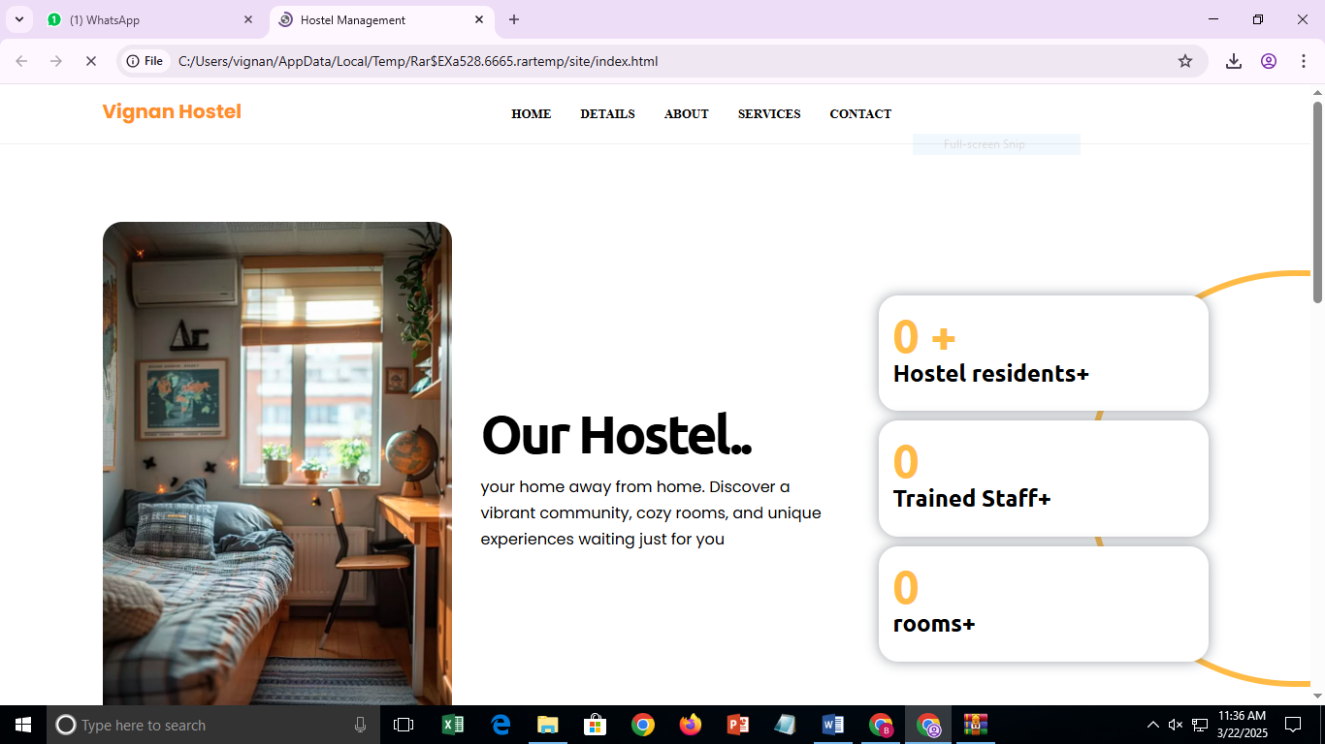

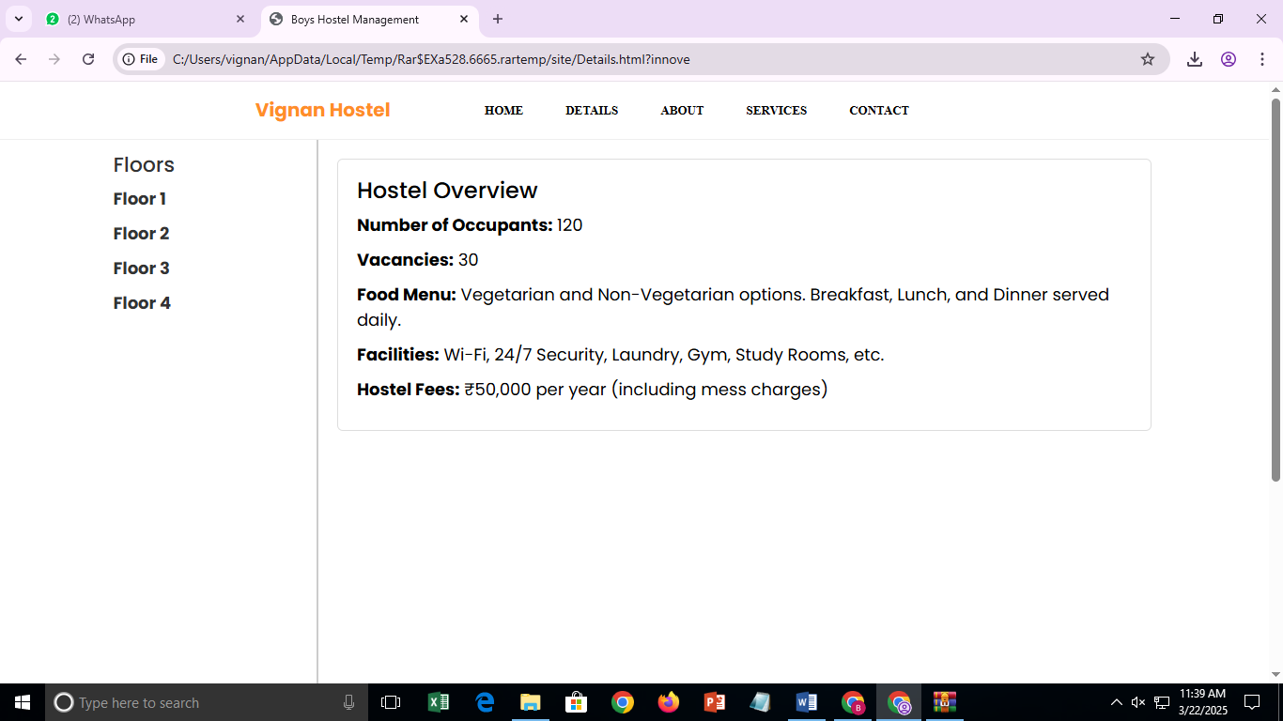

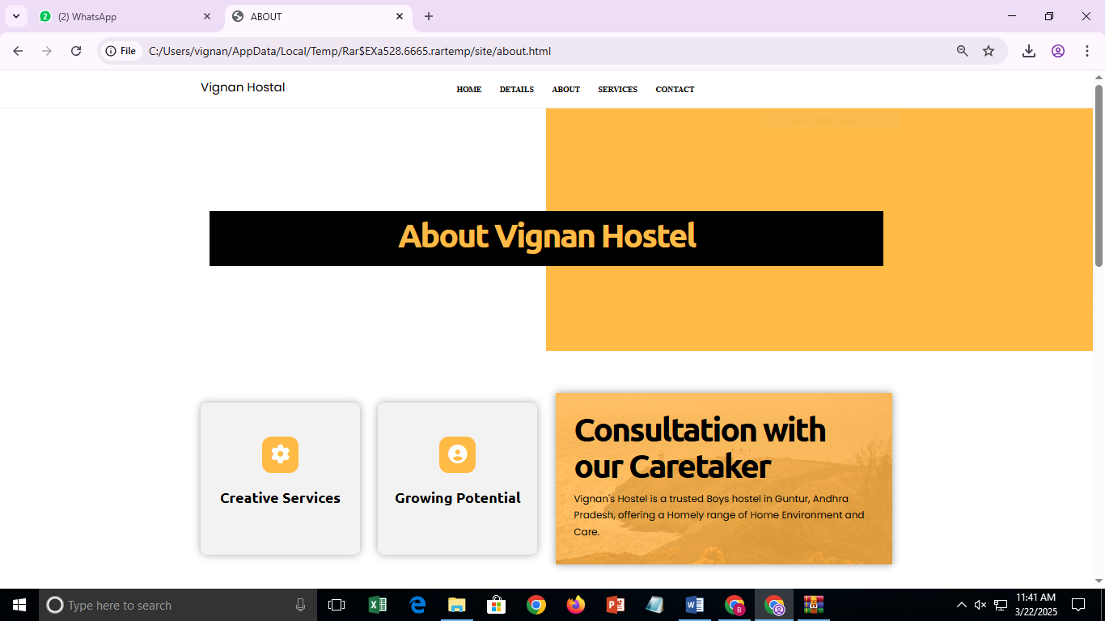

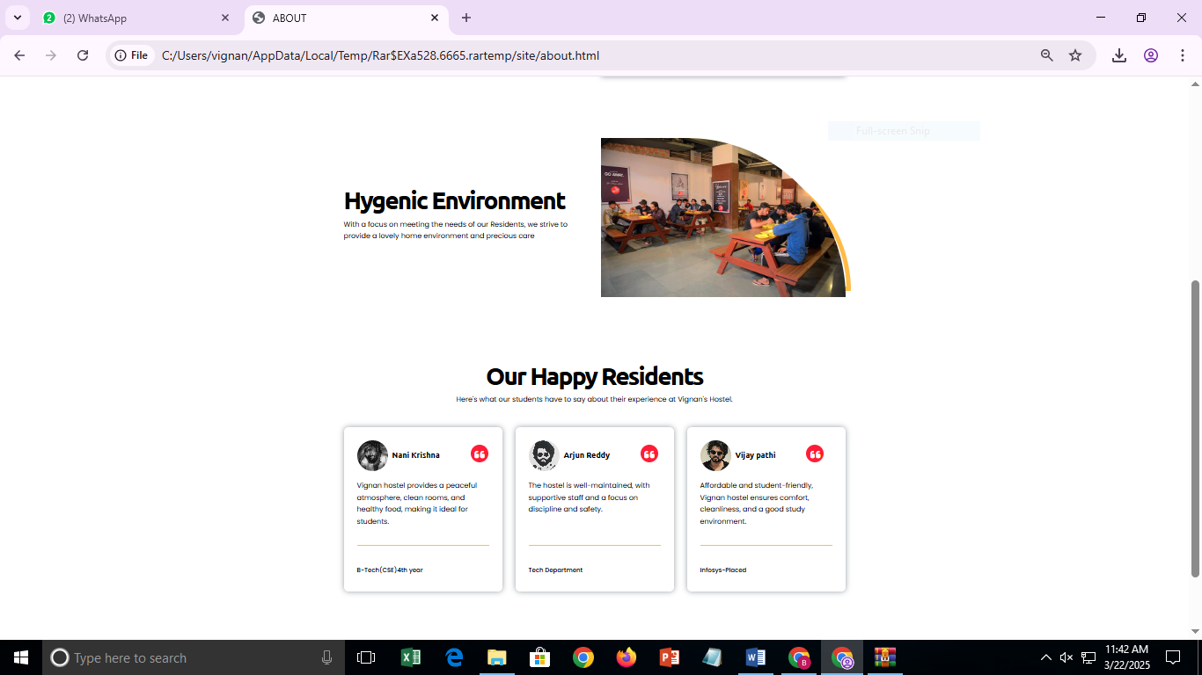

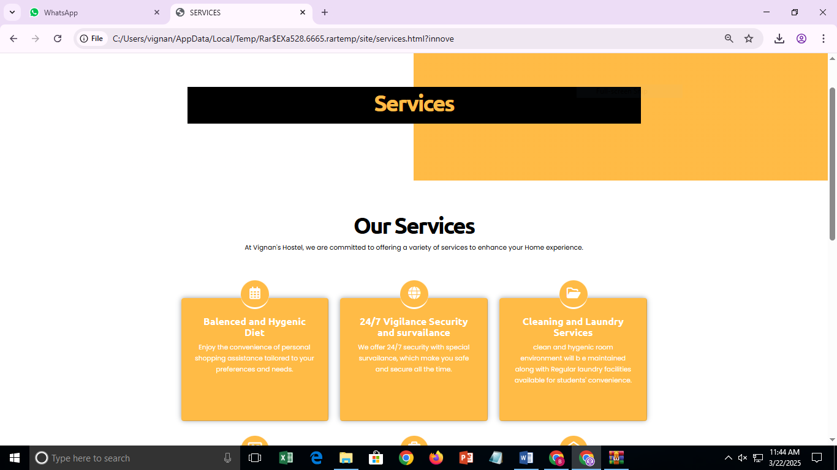

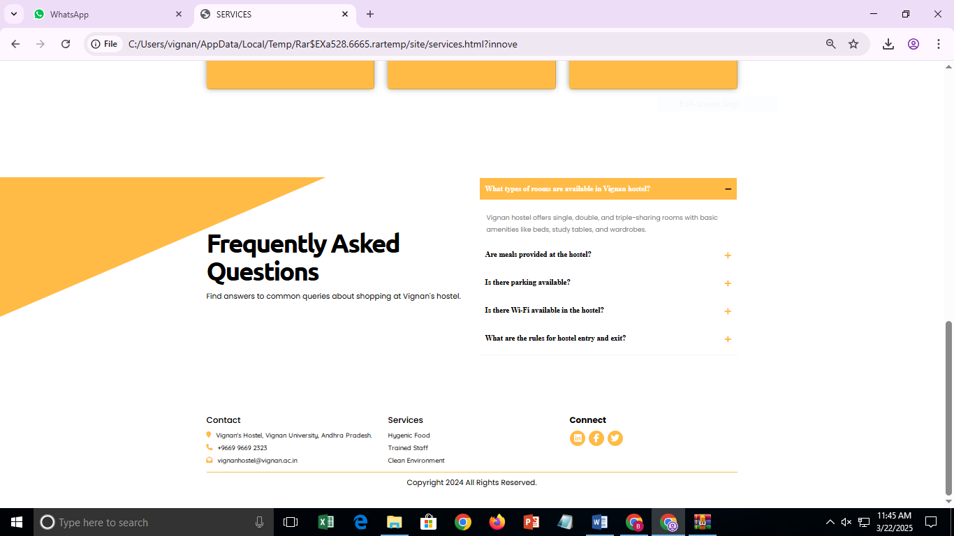

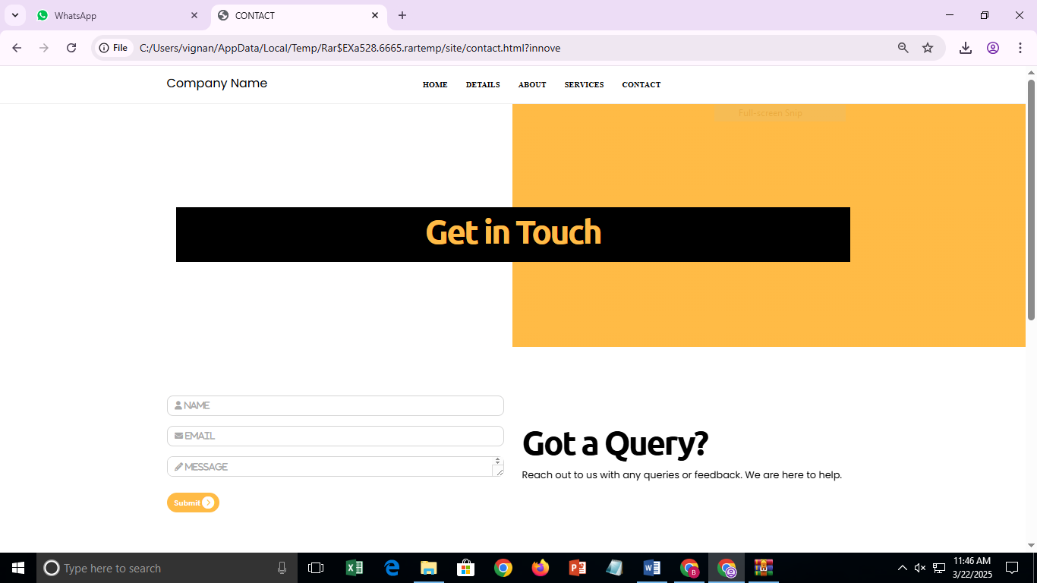

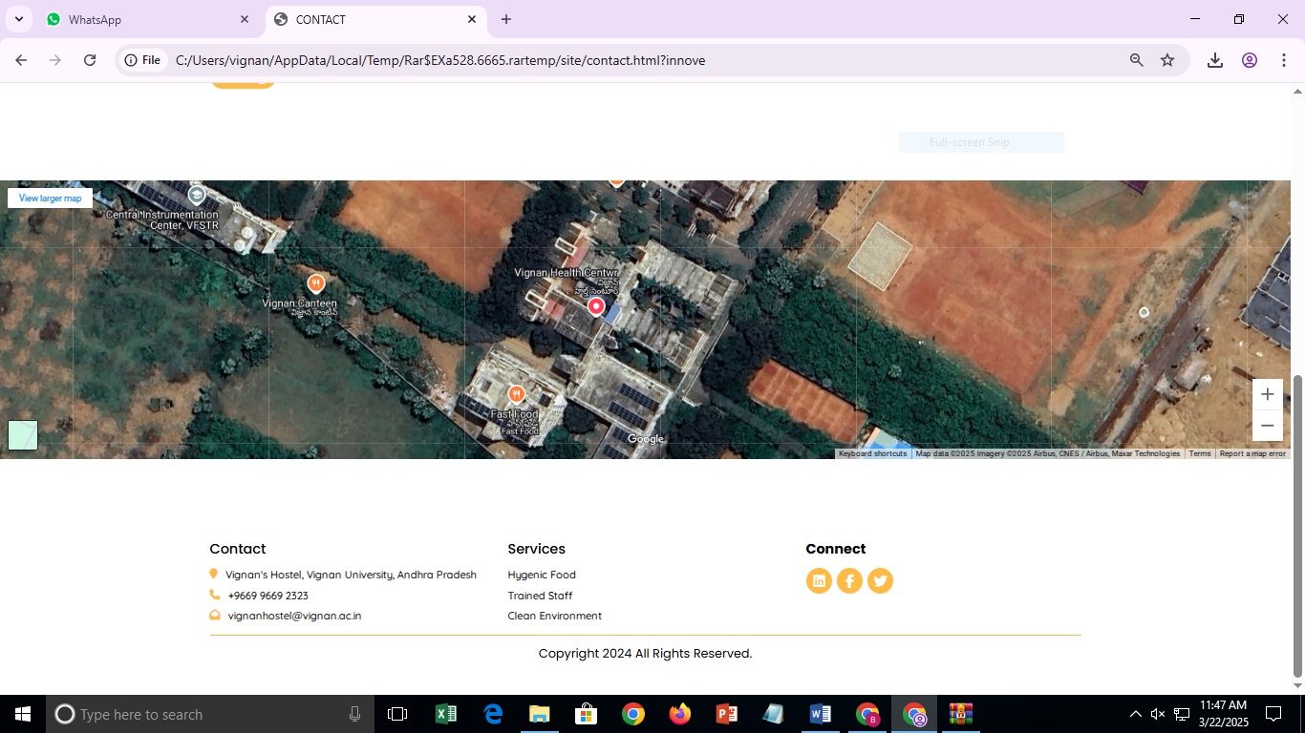

**CHAPTER 6: CONCLUSION**

The Vignan Hostel Management System successfully automates hostel operations, improving efficiency and reducing manual workload. The system allows students to access hostel details, pay fees, and submit complaints easily. It also enables administrators to allocate rooms, manage fee records, and track student complaints. Future enhancements may include database integration, online payments, and AI-based room suggestions.

**PROJECT LINK:**

<https://nareshreddygoli.github.io/HostelManangement/>

**REFERENCES**

* Web Development Technologies: HTML, CSS, JavaScript.
* Hosting & Deployment: Apache, Nginx, AWS.
* Security Best Practices for Web Applications.

This detailed version ensures a comprehensive explanation of each section, making it suitable for academic submission. Let me know if you need further refinements!